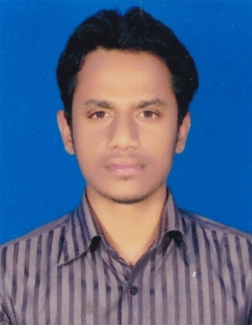
MD.Reazul Islam

248 airport Road,Sopura,Boalia,Rajshahi.

Cell No. +8801799638888
E-mail: reazulaub38@gmail.com

 Career Objective:

Looking for a challenging position where I could use my experience and interpersonal skills, creativity and knowledge in order to develop my career as well as to contribute in the welfare of the organization.
 Career Summary:
I have well capacity to communicate with others, strong motivation and commitment for the work individually and team, If I get a opportunity to work an organization I will prove myself to be an important asset through my knowledge, skill and my working creativity.
 Working Experiences:
1. Uttara Motors Ltd.
Head Office: Uttara Centre,102 Sahid Tajuddin Ahmed Sarani,
Tejgaon I/A,Dhaka-1208
Designation: Executive
Duration: 16 May 2018 To Continuing
2. Sajeeb Corporation.
Head Office: SoJeeb Corporation, Shezan Point, 2-Indira Road,Farmgate,Dhaka,Bangladesh.
Designation: Assistant Zonal Sales Incharge
Duration:February 2017 To July 2017
 Educational Background:
MBA
Major in MARKETING
Southeast University
Result: 3.38
Year: 2015-2016

BBA
Major in MARKETING
Asian University Of Bangladesh
Result: 3.41
Year: 2010 -2014

HSC
Shafiuddin Sarkar Academy And College
Result: 4.10
Year: 2009
Dhaka Board

SSC
Harbaid High School
Result: 4.25
Year: 2007
Dhaka Board

:

 Computer Skills:
✓ Basic knowledge in Computer Hardware & Maintenance.
✓ Familiar with Practical Website and Internet Application.
✓ Strong knowledge in Office Management : (MS Word, MS Excel, MS Power Point, MS
Outlook & Good Typing Speed in Both English and Bengali)
 Language Proficiency:
Bengali : As a Mother Language
English : Effective Reading, Writing and Fluent Speaking Ability.
 Specialty:
1. Friendly & Communicative.
2. Ability to suppress tension.
3. Perceptive and interested to new technology.
4. Passion to spend lot time in the fields of interest.
5. Ability to manage stuffs, and work with group.
6. Taking challenges to achieve the best result from assigned tasks.
 Other Skills and Interest:
1. Strong analytical and interpersonal communication skills .
2. Have a quick learning and adapting capabilities .
3. Using Internet & Voice chat .
4. Like to converse English with people .
5. Build up good relationship with people .
 Personal Profile:
Father’s Name : Md.Afzal Hossain
Mother’s Name : Razia Akter
Nationality : Bangladeshi (by birth)
Nationality ID Number : 19923313081000433
Marital Status : Single
Blood group : AB+
Permanent Address : Vill – Podo Harbaid , P.O – Harbaid ,
Thana – Tongi, Dist – Gazipur .
Sayed Kamal Ashraful Haque  Manager & Branch Incharge  Uttara Motors Ltd  Mob:01711881036  248,Airport,Road,Sopura,Boalia,Rajshahi. | Md.Mozzamal Haque  Area Sales Manager  SoJeeb Corporation  Mobile: 01955530490, 01916268244  Shezan Point, 2-Indira Road,  Farmgate, Dhaka, Bangladesh.
I eagerly expect your kind attention to these materials and certainly look forward for exploring this further.

(Md.Reazul Islam)
Date:

